**Exciting Ph.D. Opportunity in Algal CO2-Concentrating Mechanism at UW-Madison (2025 Fall)**

The Shan He lab in the Department of Botany at the University of Wisconsin-Madison invites applications for Ph.D. students wishing to start in Summer/Fall 2025. Our lab explores how eukaryotic algae adjust their photosynthetic strategies at the molecular level in response to fluctuating environmental changes. 🌱🔬🌟 Learn more about our research: <https://botany.wisc.edu/staff/he-shan/>.

**Qualifications:**

* Demonstrated interest in plant molecular biology research, particularly in the research of our lab.
* Bachelor’s or master’s degree with a minimum GPA of 3.00.
* Proficiency in English for non-native speakers.
* GRE (Graduate Record Examination) is not required.
* Relevant research backgrounds will be preferred but not required.
* A master's degree will be preferred but not required.
* Detailed instructions: <https://policy.wisc.edu/library/UW-1241>

**Apply Now!**

🌟 Please send your CV, undergraduate transcripts, a statement of purpose, and contact information for three referees to [shan.he@wisc.edu](mailto:shan.he@wisc.edu).

Detailed instructions: [Graduate Application Process](https://botany.wisc.edu/graduate-application-process/).

For questions, contact us at [shan.he@wisc.edu](mailto:shan.he@wisc.edu).

**About the University and the Department**

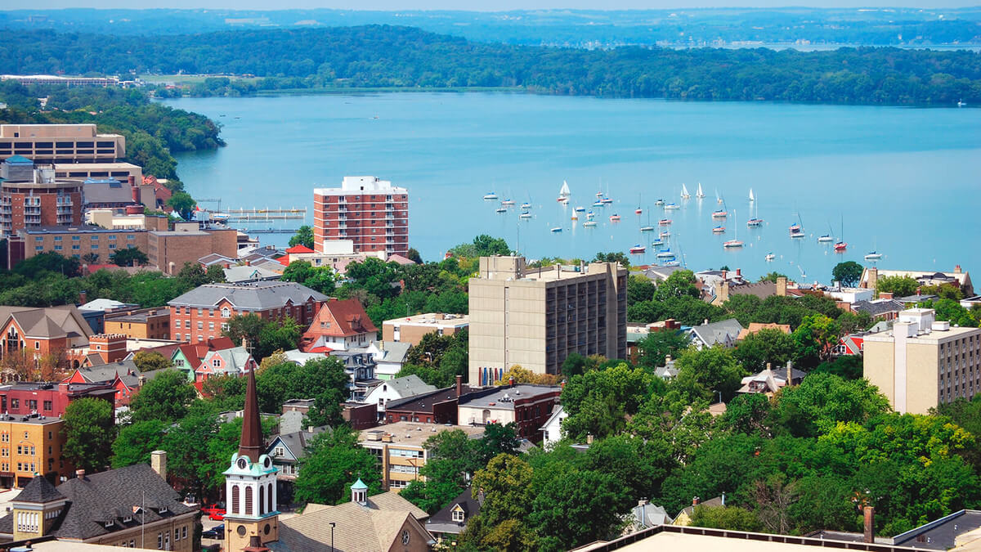

The University of Wisconsin-Madison is located in Madison, a city consistently ranked among the best places to live in the U.S. As a leader in pioneering research across various disciplines, the university provides Ph.D. students with an enriching environment for intellectual growth, offering access to state-of-the-art facilities and collaboration with world-class faculty. Beyond academics, the campus's natural beauty and cultural vibrancy make it an ideal place for both personal and professional development.

The Department of Botany at UW-Madison excels in plant sciences research and education. Known for its cutting-edge research in plant ecology, evolution, and molecular biology, the department offers Ph.D. students opportunities to engage in interdisciplinary projects addressing global challenges. It also fosters a collaborative and supportive environment that encourages students to develop their research interests and build strong professional networks. <https://botany.wisc.edu>

**Please share this opportunity with anyone who might be interested!** 🙌